Sakshi Dhamapurkar PRN:21510073

//Experiment 1 Program based on structures and pointers in C

#include<stdio.h>

struct data

{

int roll_no;

char stuname[20];

float mark;

}s[5];

int main()

{

for(int i=0;i<5;i++)

{ printf("ENTER INFORMATION OF %d STUDENT",(i+1));

scanf("%d",&s[i].roll_no);

scanf("%s",s[i].stuname);

scanf("%f",&s[i].mark);

}

for(int i=0;i<5;i++)

{ printf("INFORMATION OF %d STUDENT\n",(i+1));

printf("ROLL NO.=%d\n",s[i].roll_no);

printf("NAME OF STUDENT=%s\n",s[i].stuname);

printf("MARK OF STUDENT=%.2f\n",s[i].mark);

}

}

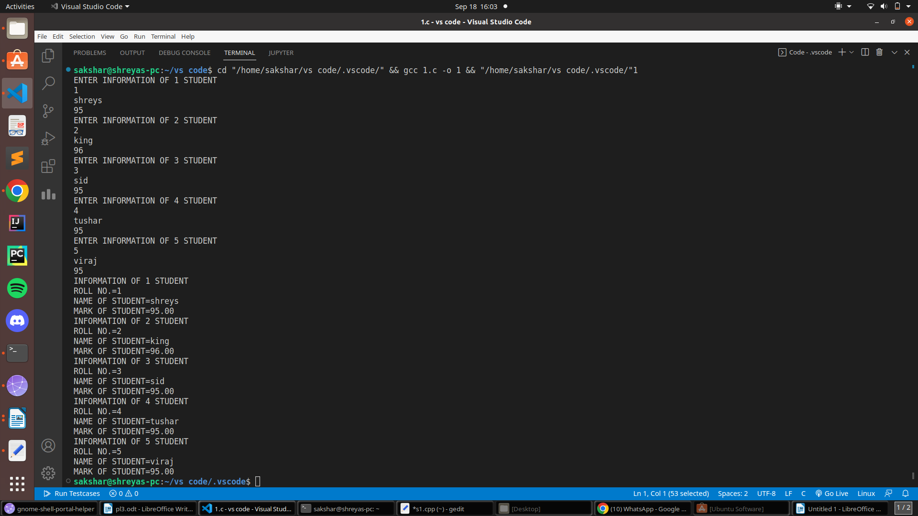OUTPUT :

// POINTER EXAMPLE //

#include<stdio.h>

void swap(int *x,int *y)

{

int t;

t=*x;

*x=*y;

*y=t;

}

int main(){

int x;

int y;

scanf("%d",&x);

scanf("%d",&y);

swap(&x,&y);

printf("%d %d",x,y);

}

OUTPUT:

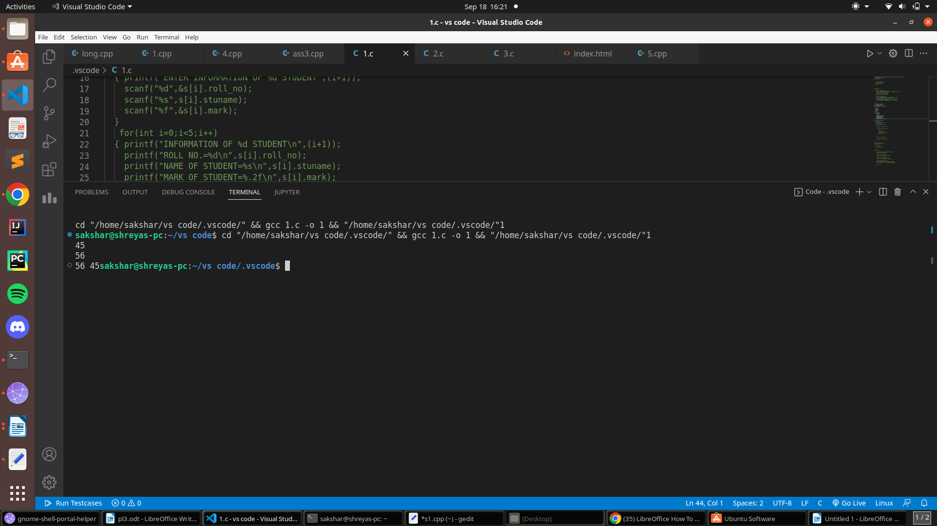

// pointer array example //

#include<stdio.h>

int main(){

int a[5]={4,5,8,1,2};

int *ptr=a;

for(int i=0;i<5;i++)

{

for(int j=i+1;j<5;j++)

{

if(*(ptr+j)<*(ptr+i))

{

int t;

t=*(ptr+i);

*(ptr+i)=*(ptr+j);

*(ptr+j)=t;

}

}

}

for(int i=0;i<5;i++)

{

printf("%d ",*(ptr+i));

}

}

OUTPUT:

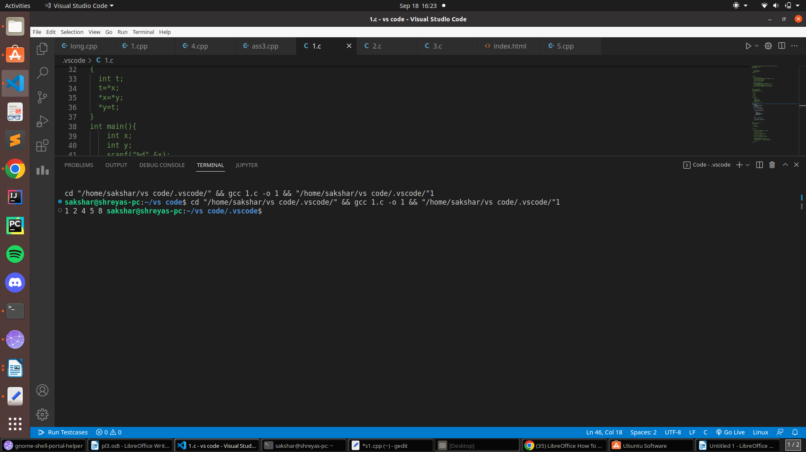

// POINTER STRUCTURE EXAMPLE

#include <stdio.h>

struct person

{

int age;

float weight;

};

int main()

{

struct person *personPtr, person1;

personPtr = &person1;

printf("Enter age: ");

scanf("%d", &personPtr->age);

printf("Enter weight: ");

scanf("%f", &personPtr->weight);

printf("Displaying:\n");

printf("Age: %d\n", personPtr->age);

printf("weight: %f", personPtr->weight);

return 0;

}

OUTPUT:

